**WALMART INC**

DIGITAL TRANSFORMATION INTERVIEW – A

**INTERVIEW**

**PROCESS**

Srikanth Reddy Narra

Z1947038

Management Information Systems

Northern Illinois University

OMIS 697 – Digital Transformation Strategies

Prof. Brian Bender

**INITIATION**

When we started a discussion on Digital Transformation interview, the person that struck to me was my cousin, Mr. Rohith Reddy Narra, who works as a Data Engineer III at Walmart Inc located in Dallas, TX, USA. I have made a conversation with him regarding the Digital Transformation Interview and its process. He agreed to share his experiences and made a formal agreement through an email and a screenshot of the email is attached below as a Figure1.

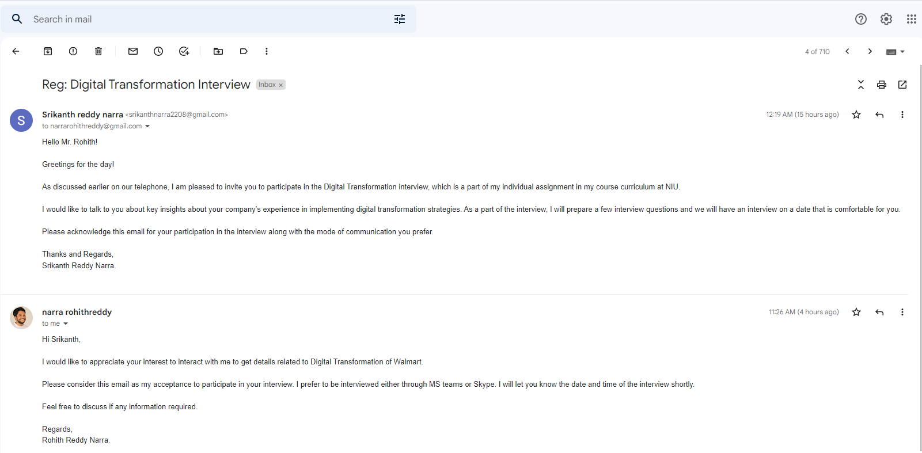

Figure 1 Showing the tentative agreement from the interviewee through email.

**NAME OF THE INTERVIEWEE**

Interviewee Name: Mr. Rohith Reddy Narra.

**NAME OF THE COMPANY**

The Interviewee works in Walmart Inc located in Dallas, TX, USA.

**ABOUT WALMART.**

As Walmart Inc is an American multinational retail corporation that operates supercenters, departmental stores, grocery stores with a global presence across 24 countries running under 46 different names. It has about 10585 stores providing employment to 2,300,000 employees throughout the world. This is well known for its goods and services provided for the lower prices, this attracts lot of customers to purchase their goods for day-to-day needs [1]. Walmart analyzes the data of customers and their sales to know the current trends of the market and target the customers based on their requirements. It is well equipped with employees of multiple domains and technologies to handle and deliver solutions to the organization to improve the business with the market trends.

Walmart Inc adapts multiple technologies for their analytics, it has recruited employees who has expertise in google data studio, python, Tableau, machine learning and few other database applications. It also invests in cross skilling their employees on multiple technologies to gain benefit of making employees understand process linkages.

**TITLE AND POSITION**

The Interviewee is working in the organization as Senior Data Engineer III, Information Technology Dept. He leads a team in domain of Data management and services; and has an expertise in the domain of legal services and solutions.

**BASIC JOB FUNCTIONS & RESPONSIBILITIES**

As a Data Engineer, Mr. Rohith Reddy Narra majorly works on designing data models throughout the Software Development Life Cycle, right from the planning phase to the project deployment phase of Software Development Life Cycle. He interacts with process owners and clients to provide solutions for their processes and possible future impacts of the new establishing process. He is a part of data management and services team, and reports to his manager. His assignments and deliverables are made in AGILE methodology where each sprint lasts for about 10 business days, which involves 10 days of analysis or 5 days of development and 5 days for testing and retrospect.

**REASON TO INTERVIEW THIS INDIVIDUAL**

The interviewee has a work experience of about 6 years and has a great exposure to business in sales and marketing, and legal services. He has exposure in analyzing customer demographics using Tableau in collaboration with tools like informatica, Oracle DB, Phyton code and SQL studio. He predicts the pricing for the legal service and solutions with the acquired analytical reports. In addition to this, he is involved in developing and architecting data pipelines to bring in third party data into Walmart to provide analytics on sales by enabling third party data to down streams analytics and data science teams for further business improvements. As we all know Walmart Inc being one of the digital masters has great revenue and sales by attracting customers of multiple ranges and interests. Its strategy of business changes as per the customer needs and geography to be successful in the competitive business industry. As a part of digital transformation, the interviewee gives an insight on his previous experience on how the product pricing is decided by customer demographics using analytical tool Tableau. This is a part of Digital Transformation Interview he had engaged in past and where in present employment at Walmart Inc, he is involved in enabling the third-party data for downstream analytics and data science within the organization for developing and architecting data pipelines using google studio analytic stool, Scala, Presto, Phyton technologies which will provide best methodology to adhere for better customer satisfaction contributing towards the organization revenue and profits.

**CONTACT METHODOLOGY**

The interviewee can be contacted on Skype or MS teams based on his convenience.

**REFERENCES**

1. Wiki: https://en.wikipedia.org/wiki/Walmart#Former_stores_and_concepts